(Attachment 3)

INTERNATIONAL CONFEDERATION OF
THE APOSTOLATE OF THE SUFFERING (CVS)
Three-Year Pastoral Guidelines 2021-2023
HEALING THE WORLD
A Prophesy for Salvation
“The pandemic continues to cause deep wounds, exposing our vulnerability. . .. Thus, we must keep our gaze firmly fixed on Jesus. . . . and with this faith embrace the hope of the Kingdom of God that Jesus Himself brings us. A Kingdom of healing and of salvation that is already present in our midst. . . . Renewed contact with the Gospel of faith of hope and of love invites us to assume a creative and renewed spirit. In this way, we will be able to transform the roots of our physical, spiritual, and social infirmities. . . .Jesus’s ministry offers many examples of healing. . . . He heals not only the physical evil—which is true, physical evil—but He heals the entire person. . . .And so we can ask ourselves: today, in what way can we help heal our world? As disciples of the Lord Jesus, who is the physician of our souls and bodies, we are called to continue ‘His work, work of healing and salvation.’”
Pope Francis
(See website: The Holy See, Pope Francis’ General Audience, August 5, 2020)

These are the Three-Year Pastoral Guidelines 2021-2023. They follow Pope Francis’ teachings on “Healing the World.” These guiding concepts are particularly relevant because of the times in which we live. We are sent out with the mission to bring the Lord’s Word into the world spreading healing and salvation. We are prophets not in the sense of foreseeing the future, but those who witness and share the Word of God’s love today. Thus, “Healing the World” is related to prophesy by studying some Biblical Prophetic Books.

Three Thematic Approaches – One for Each Year
- Wisdom - 2021-2022
- Service – 2022-2023
- Love – 2023- 2024
These are to be evaluated and are to be a source of meditation and apostolic action. There is a prophetic theme in all of these three.
First, we must focus on our prophetic mission that has to have a concrete commitment through our activities and messages to mirror God’s vision and action for the salvation of the world.
In our prophetic approach, we must analyze the world in which we live. Is there something to change, modify, improve, or cure leading man to salvation? This is in opposition to our passivity, superficiality, egoism, inconsistency, and fear. We can affront these problems through wisdom, service, and love that will cure the pain and suffering in the world.

In our Apostolic Activities, we must admit that we need to cure the afflictions of the Apostolate of the Suffering (CVS) so as to heal our shortcomings and thus the Apostolate can demonstrate its “prophetic role” to fortify the world.
This process begins with our own inner healing, our vision for the Apostolate, and our understanding of the needs of our particular country.

The Marian aspect is very important in the Apostolate. “Praying” to the Blessed Virgin is central and her words should be guidelines for our actions. In particular, we should say the rosary contemplating the mysteries as a way of teaching us the road to salvation. We should choose a prophetic Biblical text to meditate and to be the basis for our apostolic activities. We must organize to find concrete ways to cure a broken world through specific proposals for action. We should have the heart of Mary in our prayers, and she is our role model as our guiding light.
Three portraits of the Blessed Virgin that our Founder admired will light our spiritual path:

First year: Wisdom – The Blessed Virgin of Silence;
Second year: Service – The Blessed Virgin of the Broom;
Third year: Love – The Blessed Virgin of Christ’s Monstrance.

The Blessed Virgin of Silence is a wooden statue. There are four different types in which Mary places her finger on her mouth. It is in the Immaculate Heart of Mary Cathedral in the crypt. The statue leads one to meditate on Wisdom. This is not intellectual, but spiritual focusing on a biblical study of the Gospel seeing its truth and beauty.

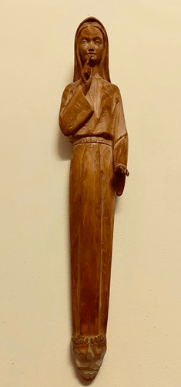

The Blessed Virgin of the Broom is a small marble statue that indicates the importance of daily work in the home. Mary can be imagined working in her home in Nazareth. It emphasizes how serving is a daily mission in which one offers himself/herself with humility.

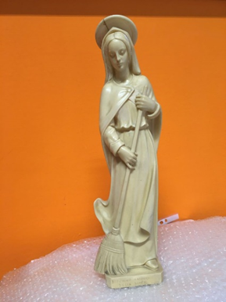

The Blessed Virgin of Christ’s Monstrance is a sterling silver monstrance that has been donated by some individuals. The Blessed Virgin has her arms raised holding Jesus in the Eucharist. She is offering Him to a sick world. In fact, there are simple people and sick people at her feet that offer themselves to be cured. This shows the importance of love, the theme of this third year. Jesus emblematic of love and giving love offers Himself as an ever-precious gift.

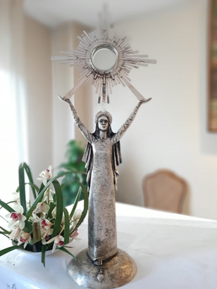

Biblical texts:

Since the Confederation is composed of different groups from various cultural contexts, every group may choose from the Prophetic / Wisdom Books of the Bible for each year. These passages should be meditated and studied in depth so as to be a source of prophetic apostolic action.
The Confederation suggests the following:

First year: 2021-2022 – Wisdom theme: Book of Wisdom
Second year 2022-2023 – Service theme: Book of Jeremiah
Third year 2023-2024 – Love theme: Book of Hosea

Conclusion:

“Inspired by love and convinced of our faith in the Lord’s infinite mercy, we must bring to humanity the requests of the Blessed Virgin that many have abandoned or forgotten. The world must be saved, but salvation has come and will continue to come from the Cross of Our Lord Jesus Christ.
What is missing from Christ’s passion? My loving offering of my suffering that is the fruit of His love for us.
These are important times, and we cannot permit ourselves to live on the margin of society forgetting our vital role in the present. We must be witnesses of Christ: ‘The great prophet who as a role model proclaimed the Word and the Kingdom of the Father. His prophetic example showed His glory not only to the hierarchy, but also to the laity who witness His example.’ (LG 36) Each of us in every walk of life has to follow his own personal vocation modeling his life on Christ’s.” Luigi Novarese,
The Anchor, April 4, 1966, pp. 1-4).

Our founder’s comments should inspire us to fully commit ourselves in the Apostolate so that our work is a prophesy for salvation, a singular role vital for humanity. (CVS Constitution, Purpose)

As Pope Francis said during his visit to Iraq, “How easy it is to fall into the trap of thinking that we have to show to others how strong we are, how wise we are. We can fall into this trap thinking falsities about God and our feelings of security. In reality, things are completely different. All of us need God’s power and wisdom, revealed in Jesus on the Cross. He offered to the Father on Calvary the wounds of which we have been healed (1Pt 2: 24) Here in Iraq, how many of your brothers and sisters, friends and companions have war wounds, have real visible and invisible wounds? The temptation is to respond to these painful things with human force, with human wisdom. Instead, Jesus shows us the path of God, that which he has gone down and that He asks us to follow.”

Pope Francis’ comments show that love can only cure the suffering of humanity that has been wounded. They should guide us with frankness, courage, and simplicity as we move ahead living the Apostolate.

